- List all employees whose last names begin with P.
SELECT f_name, l_name
FROM employee_data
WHERE l_name LIKE 'P%';
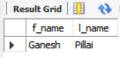

- Display the names of all employees in the marketing division.
SELECT f_name, l_name
FROM employee_data
WHERE title = 'Marketing Executive';
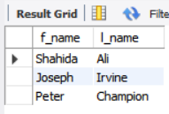
- What will the following SELECT statement display?
SELECT f_name, l_name, salary
FROM employee_data
WHERE f_name LIKE 'k%';
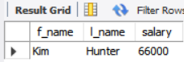
f_name LIKE 'k%'
→ selects all employees whose first names start with the letter K.
- List the last names and titles of all programmers.
SELECT l_name, title
FROM employee_data
WHERE title = 'Programmer';
